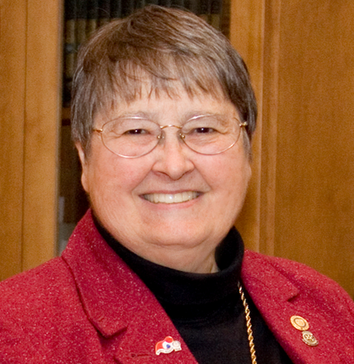
Janice H. McElroy Scholarship
Jan was born and raised in the wheat and cattle country of Kansas and later lived in Denver. She majored in Chemistry at Colorado College before going to the University of Cologne, Germany as a Fulbright Scholar in Biochemistry. Jan taught science in Baltimore and earned her masters at Johns Hopkins. She served as chair of the science department at the Bishop’s School in La Jolla, California, before she completed her Ph.D. in Human Behavior.
Jan, her husband Jim, and their two children moved to New Jersey and later Pennsylvania, where she became very involved in the American Association of University Women serving four years as State President of AAUW and four years on AAUW’s national Board of Directors. In 1988 she accepted a gubernatorial appointment as Executive Director of the Pennsylvania Commission for Women. Her proudest accomplishment in that role was the creation of the Leadership Development Institute for Women in State Government and getting it transitioned to the next administration. In 1998, she ran unsuccessfully for Congress in the PA 15th
In 1999, she moved to Henniker to be the Assistant to the President and Director of Planning at New England College. In 2005, she joined the development staff at Colby-Sawyer College as their Grants Manager until her retirement in 2009.
Jan McElroy’s Rotary Legacy
Jan joined the Henniker Rotary Club in 2000 and served as its President in 2004—05, receiving the Presidential Citation for the club. She received the Rotarian of the Year Award in 2008. Jan served 3 years as an Assistant Governor, as District Rotary Foundation Chair and as Secretary of the District 7870 Foundation. She is a multiple Paul Harris Fellow and was a member of the Rotary Leadership Institute Faculty. Her travels took her throughout Europe, Japan, China, Ghana and all fifty United States. During her year as District Governor 2011-2012, Hurricane Irene devastated southern Vermont. Representing District 7870, Jan partnered with Marilyn Bedell, her counterpart in Vermont’s District 7850, to submit a matching grant to The Rotary Foundation to help with Vermont’s long-term recovery. They secured pledges from individuals and 114 Rotary Clubs around the world and ultimately received an RI grant of $412,000 –the largest RI grant ever awarded for a US project. Jan was invited to present at the International Rotary Conference, but had been recently diagnosed with cancer and was unable to attend. Still, she narrated a multi-media presentation which was shown at the conference.
After a valiant struggle, Jan died in the winter of 2014. Prior to her death, she decided what she would like her legacy in Rotary to be. She asked that a fund be set up to award scholarship assistance to non-traditional students that was open to eligible youth 21 and over from throughout the district to attend post-secondary education in a 2 or 4 year program.
District 7870 is proud to honor Janice’s service to Rotary, the district and the world with the announcement of the Janice H. McElroy Scholarship for Non-Traditional Students.
Eligibility
This scholarship fund is to be used to support the college education of non-traditional students from Rotary District 7870. Applicants must be 21 years of age or older and must have completed high school or have earned a G.E.D. There must be at least a three-year gap between graduating from high school and full time college attendance or a record of part-time college for three years after graduating from high school.

Scholarship recipients earning a B average or better may apply for a subsequent year of support, allowing the possibility for support to continue until the supported course of study is completed. The scholarship can be used for expenses at a four- year or a two- year college, or for another type of accredited institution.

A committee consisting of representatives from District 7870 will determine the recipient each year and the scholarship, of at least $1,000 will be presented at the annual District Conference.

